Serverless Image Processing Project Details
This document provides a comprehensive overview of a serverless image processing solution implemented on Amazon Web Services (AWS). This system automatically resizes and optimizes images uploaded to an AWS S3 bucket, enabling on-demand image transformations without the need for custom code management.
Project Overview
This project delivers a highly scalable, cost-effective, and automated solution for transforming images (such as resizing, optimizing, or changing formats) as they are requested, rather than pre-processing them. This approach eliminates the need for managing servers or writing custom compute code for image manipulation.
Key Technologies Utilized
This solution is built upon AWS's pre-built "Dynamic Image Transformation for Amazon CloudFront" solution. This approach ensures that the user does not need to write or manage any Python or Lambda code directly.
- Amazon S3 (Simple Storage Service): Serves as the primary storage for both original, high-resolution images and the processed/optimized versions.
- Amazon CloudFront: Functions as a Content Delivery Network (CDN), delivering images rapidly to users worldwide and acting as the public-facing endpoint for image requests. It also caches processed images for faster delivery on subsequent requests.
- AWS CloudFormation: Employed to automatically deploy the entire solution infrastructure from a predefined template. This includes setting up all necessary AWS services in a cohesive manner.
- AWS Lambda (Managed by Solution): A serverless compute service that executes the core image processing logic. This component is integral to the solution but is entirely managed by the AWS service, eliminating the need for direct user interaction with its code.
- Amazon API Gateway (Managed by Solution): Acts as the entry point for requests that trigger the Lambda function for on-demand image processing, seamlessly integrated with CloudFront.
Implementation Approach: Code-Free Deployment
This solution is achieved without writing any custom AWS Lambda or Python code. Instead, we leverage the "Dynamic Image Transformation for Amazon CloudFront" solution provided by AWS. This is a pre-built, comprehensive AWS CloudFormation template that automates the deployment and configuration of the entire image processing pipeline.
The core principle is that images are processed on-demand whenever a user requests them with specific resizing or optimization parameters (ee.g., image.jpg?width=200). If a resized or optimized version does not yet exist, the solution generates it and stores it for future requests. This entirely eliminates the need for manual coding or server maintenance.
To transform images, users simply append query parameters directly to the CloudFront endpoint URL, specifying the desired transformations such as width, height, format, or quality. This built-in query capability makes image manipulation straightforward and highly accessible.
Key Benefits
- Serverless: No servers to provision, manage, or patch. AWS handles all underlying infrastructure.
- Automatic Scaling: The solution automatically scales to accommodate any volume of image requests, from a few to millions.
- Cost-Effective: You only pay for the resources consumed (S3 storage, CloudFront data transfer, Lambda invocations), leading to significant cost savings compared to traditional server setups.
- On-Demand Processing: Images are transformed only when requested, conserving processing power and storage by avoiding the creation of unnecessary image versions.
- Global Delivery (CDN): CloudFront caches images at edge locations worldwide, ensuring low-latency access for your users.
- Zero Code Management: Deploy a robust and powerful image processing solution without writing or maintaining complex image processing code yourself.
API Endpoint and Usage
Upon successful deployment of the CloudFormation stack, the primary API endpoint for image requests will be a CloudFront domain name. This URL will be used to access and transform your original images.
Example API Endpoint: https://d3ausgavq86wyb.cloudfront.net
Example URL for requesting a transformed image: If your original image photo_02.jpg is uploaded to the root of your source S3 bucket, you can request a 200-pixel wide version using: https://d3ausgavq86wyb.cloudfront.net/photo_02.jpg?width=200
Here is the link to the project:
https://d3ausgavq86wyb.cloudfront.net
Please provide the image and query yourself.
Project Screenshots
Here are visual references illustrating the key stages of this project's setup and operation:
- S3 Bucket with Uploaded Images:
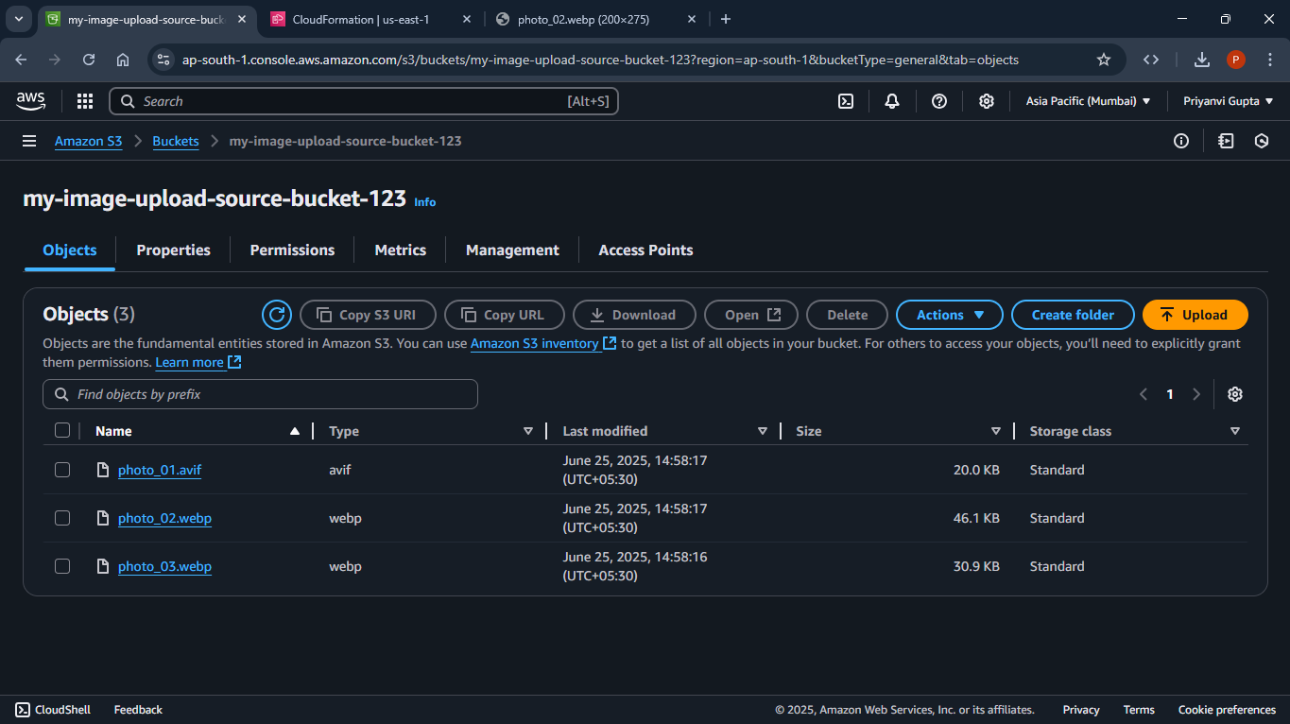

- CloudFormation Deployment Progress:
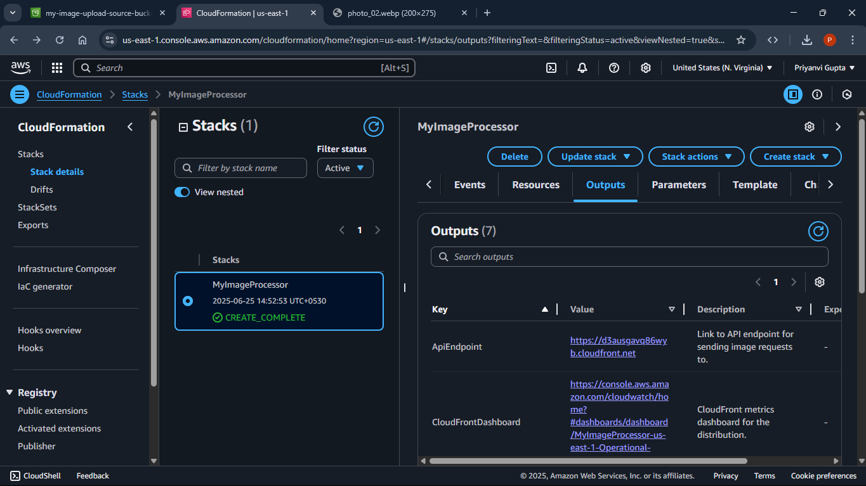
- Transformed Photo Accessed via URL:
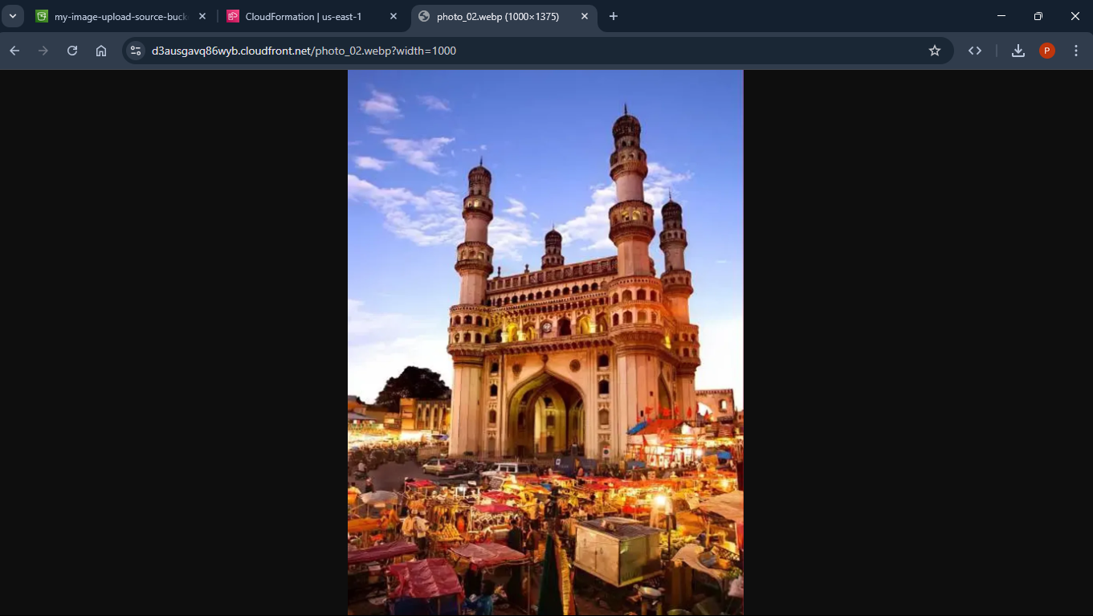
Feedback
We welcome your feedback on this documentation and the serverless image processing solution. Please let us know if you have any questions, suggestions for improvement, or encounter any issues. Your input is valuable for enhancing this project
Let's Connect
Feel free to connect for any questions, collaborations, or further discussions about this project or serverless architectures. Your feedback is highly valued!
EMAIL: priyanvigupta869@gmail.com
LINKEDIN: https://www.linkedin.com/in/priyanvi-gupta-993590322/

